GNU Octave, version 3.8.2
Copyright (C) 2014 John W. Eaton and others.
This is free software; see the source code for copying conditions.
There is ABSOLUTELY NO WARRANTY; not even for MERCHANTABILITY or
FITNESS FOR A PARTICULAR PURPOSE. For details, type 'warranty'.

Octave was configured for "i586-pc-linux-gnu".

Additional information about Octave is available at http://www.octave.org.

Please contribute if you find this software useful.
For more information, visit http://www.octave.org/get-involved.html

Read http://www.octave.org/bugs.html to learn how to submit bug reports.
For information about changes from previous versions, type 'news'.

a = 1.000000
l = 1.000000
T = 0.010000

ε =
1.0000e-10

n = 40
k = 16
hx = 0.025000
ht = 0.000625

Начальное возмущение =
0.1 * sin(2 * pi * x)

Всего демпферов: 2

Демпфер # 1

x_1 = 0.250000

Верхнее предельное значение w_1(t) =
NaN

Нижнее предельное значение w_1(t) =
NaN

Управляющая функция w_1(t):
51.5127
80.0610
-8.1172
-106.2683
79.1302
47.1881
159.2607
-34.2489
48.7500
126.4735
112.7745
-170.3234
249.3582
-336.4900
390.9203
-60.4179
-137.2152

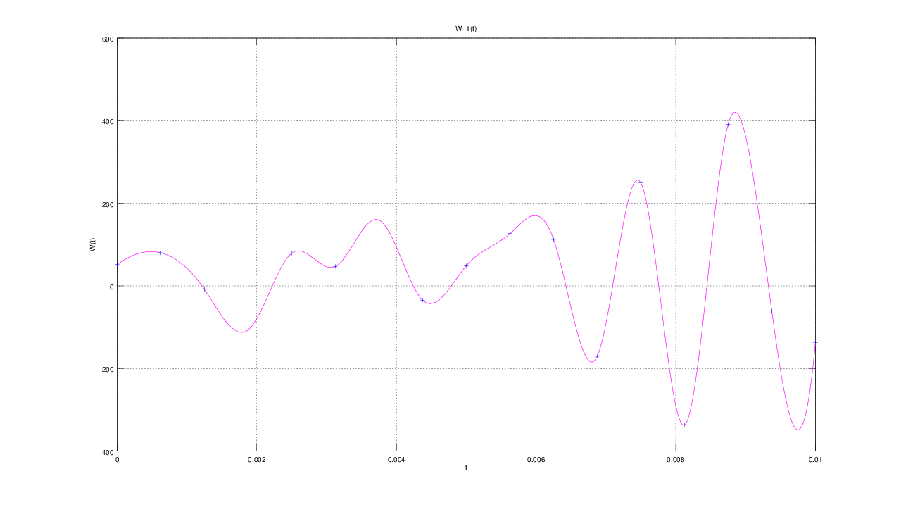

Демпфер # 2

x_2 = 0.750000

Верхнее предельное значение w_2(t) =
NaN

Нижнее предельное значение w_2(t) =
NaN

Управляющая функция w_2(t):
-50.2213
-80.1493
4.3225
118.0353
-103.3611
-7.9189
-211.7284
91.4206
-94.9910
-112.3422
-71.8901
54.8875
-47.8189
47.8448
-23.9218
-370.6354
618.6453
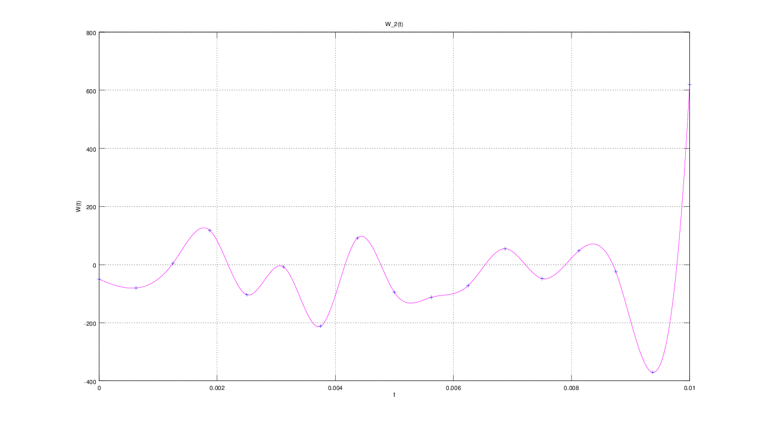

E(T) =
0.19718

u(x, t)
